Week 6 ***Todo:***Python implementation for:  
 Task 1:  
 get numOne  
 get numTwo  
 total = numOne + numTwo  
 display total  
 Task 2:  
 Get houseCost  
 Get landSize  
 Get landCost  
 totalLandCost = landSize * landCost  
 totalCost = totalLandCost + houseCost  
 display totalLandCost  
  
 Task 3:  
 Get height  
 Get weight  
 Calculate BMI (BMI = weight/(height^2 ))  
 Show BMI  
  
 Task 4: No need, already done in lecture demo.  
  
 Task 5:  
 Generate a random number between a range. (refer to get_lucky_no() in lecture demo)  
  
 Task 6:  
 Calculate leap years  
  
 Task 7:  
 Excel exercise, end results:

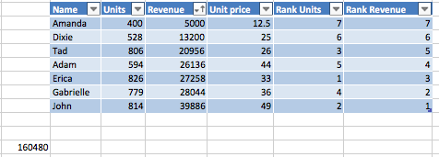

Pycharm  
  
https://github.com/yokyen/2016_summer.git